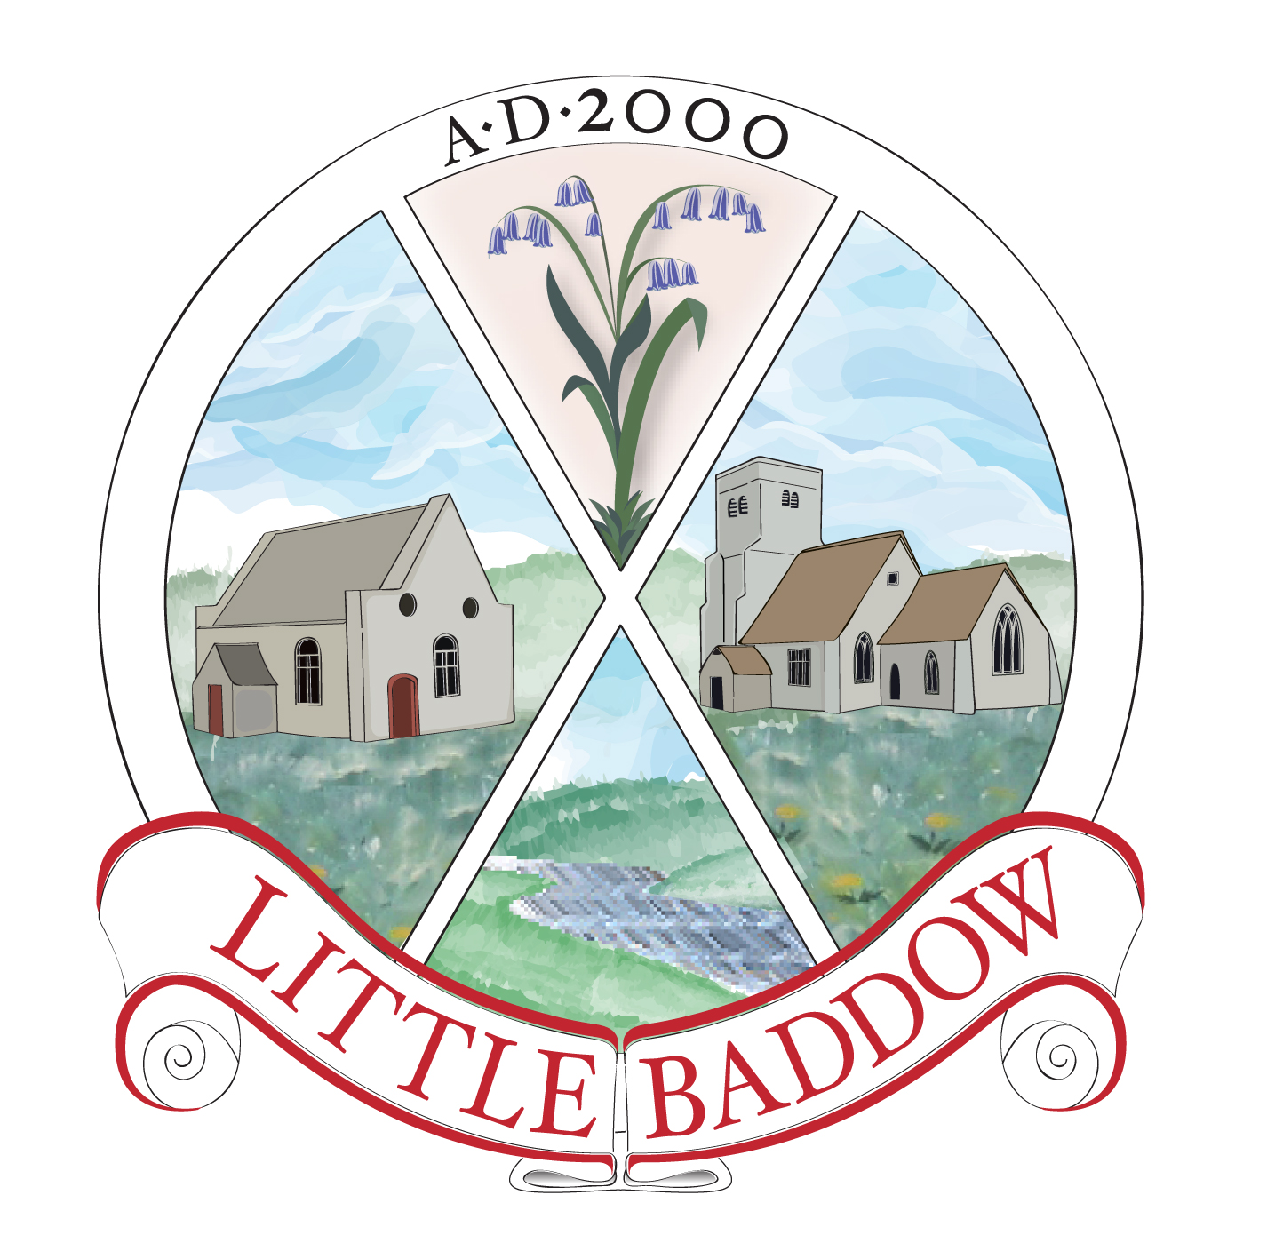

Little Baddow Parish Council

PROVISIONAL MEETING DATES 2023

January 5
February 2
March 2
April 6
May 9 (Annual)
May 10 (Wednesday) Parish Assembly
June 8
July 6
August 3
September 7
October 5
November 2
December 7

Council meetings are the first Thursday of the month except May and
June.

Parish Clerk
December 2022

