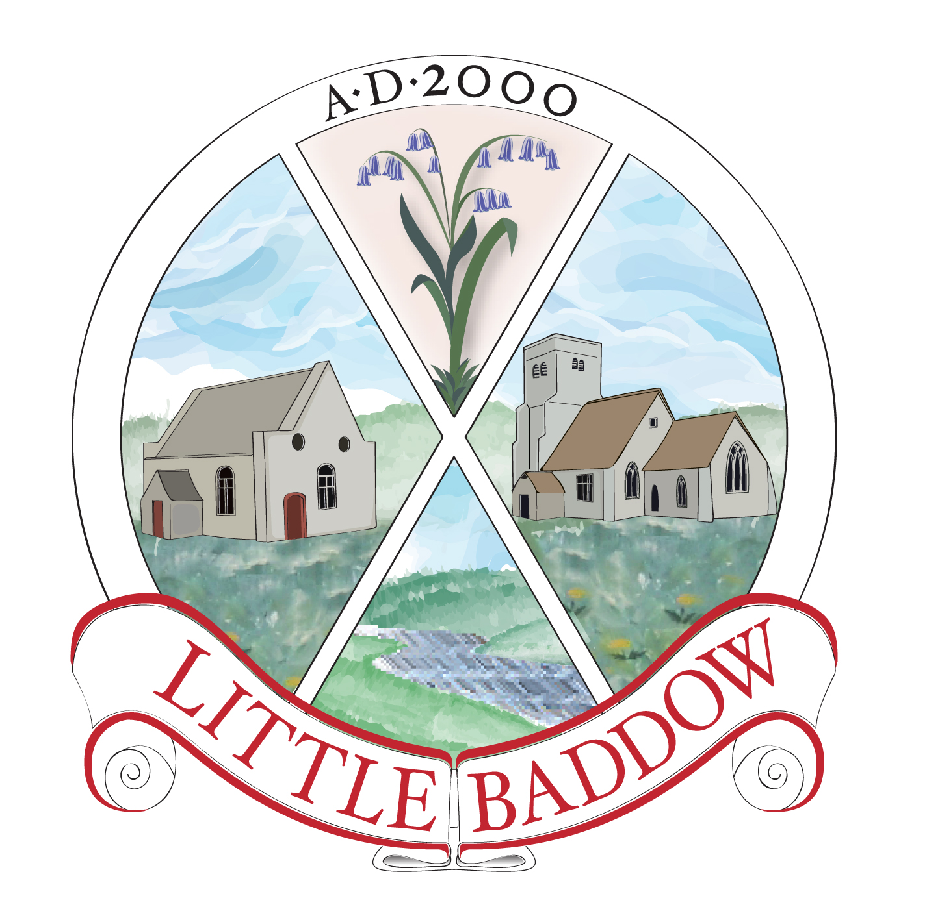

LITTLE BADDOW PARISH COUNCIL – AGENDA
The Agenda for the next meeting of the Little Baddow Parish Council which will be held at The Memorial Hall, Little Baddow on Thursday the 7th day of November, 2013 at 7.30pm is as follows:-
1. Apologies for Absence
2. Declaration of Interests
3. To approve the minutes of the October 3, 2013 meeting
4. Matters from Prior Meetings (for information)
5. Public Question Time
6. Development in the Village
7. To Receive Correspondence
8. Payment of Accounts
9. Memorial Hall (Councillor Cooper)
- review status of hall extension building work/outstanding issues
- review and agree proposal for improved marketing of the Hall
- agree expenditure for advertising leaflet
- agree expenditure for display boards
- review status of improved control of heating system
- agree proposal for locked storage cupboards
- agree expenditure to repair kitchen roof
10. War Memorial (Councillor Cooper)
- agree location for the proposed memorial and the level of Council support
- advise projected annual maintenance costs
11. Spring Newsletter (Councillors Shepherd)
- agree content and size of articles
12. 2013-14 Budget (Councillor Willington)
- review draft budget
- agree actions required to support budget approval in December
14. Village Fete (Councillor Willington)
- agree committee structure
15. Youth Facilities (Councillor Robinson/Shepherd)
- feedback from Youth Council meeting and agree next steps
16 Spring Close Play Area (Parish Clerk)
- agree expenditure for tree removal
17. 2014 Meeting Dates (Parish Clerk)
- agree meeting dates
18. Information Items
19. Date of Next Meeting: Thursday December 5, 2013

The Public and Press are cordially invited to be present.

Signed: Parish Clerk
November 1, 2013

