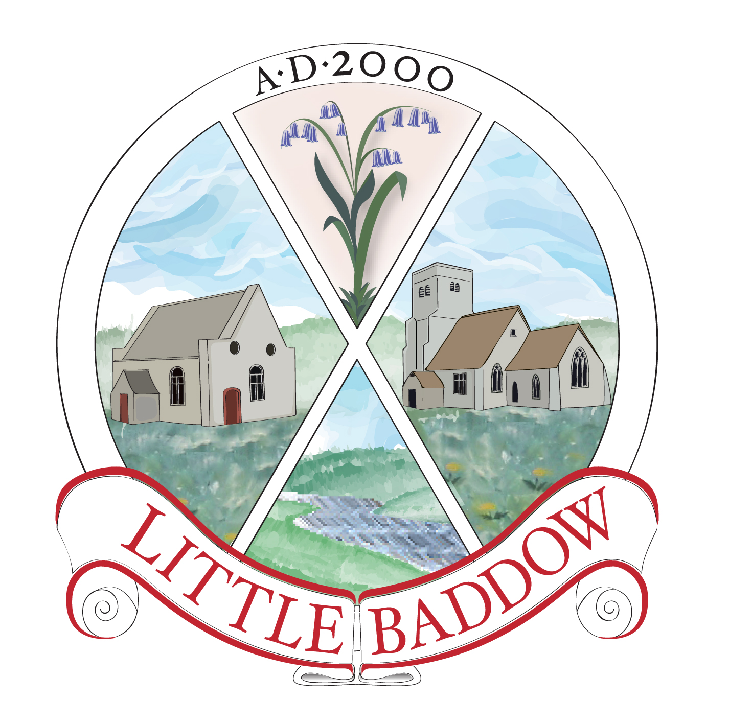
PLANNING COMMITTEE AGENDA

The agenda for the Planning Committee Meeting of the Little Baddow Parish Council which will be held at The Memorial Hall, Little Baddow on Thursday the 8th of August, 2013 at 11:00am is as follows:-

1. Apologies for Absence
- Declaration of Interests
3. Public Question Time
- Development in the Village

13/00832/FUL Coppins, North Hill
Single storey side extension

13/01011/FUL Gavea, The Ridge
New hip to gable roof extensions to provide first floor accommodation. Front and rear dormer windows, single storey side, front and rear extensions, new detached garage and new fence.

13/00998/FUL 1 Jarvis Field
Two storey side and rear extensions.

13/00846/FUL Land south of Windward, North Hill
Erection of two detached two storey dwellings and associated garages.

13/01055/CLEUD Bassets Farm, Tofts Chase
The use of land for the storage of caravans

5. Land adjacent to Sandpit Cottage
-review correspondence and agree next steps
6. Information Items

The public and press are cordially invited to attend.

R A Upward
Parish Clerk
August 1, 2013

